SF.SmokeTestScripts_TC_SF_OBAccountsLandingPage_Instance1_18-Apr-2017_12-03-52_AM_Invoke_Application.png



SF.SmokeTestScripts_TC_SF_OBAccountsLandingPage_Instance1_18-Apr-2017_12-04-05_AM_Login.png

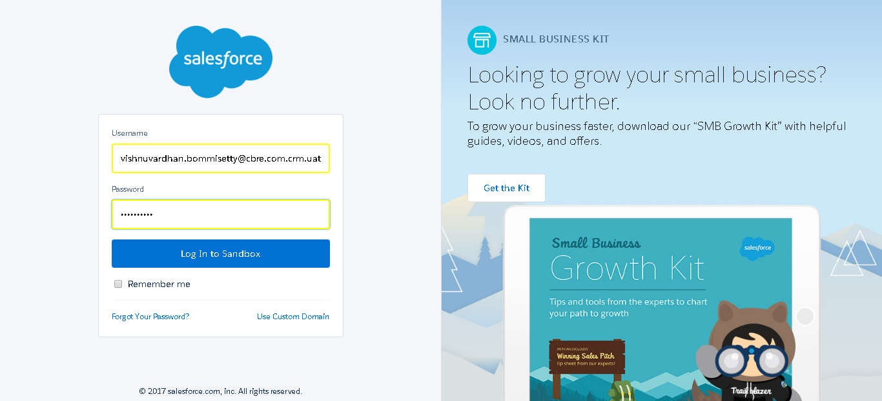

SF.SmokeTestScripts_TC_SF_OBAccountsLandingPage_Instance1_18-Apr-2017_12-04-20_AM_Verify_Login.png

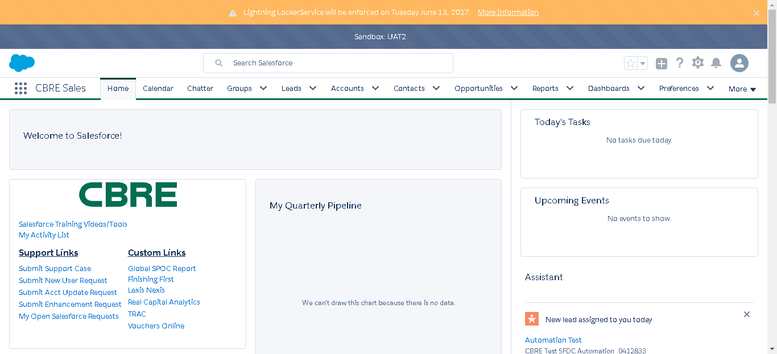

SF.SmokeTestScripts_TC_SF_OBAccountsLandingPage_Instance1_18-Apr-2017_12-04-35_AM_Verify_Menu_-_Accounts.png



SF.SmokeTestScripts_TC_SF_OBAccountsLandingPage_Instance1_18-Apr-2017_12-04-39_AM_Verify_Accounts_Home_Page.png

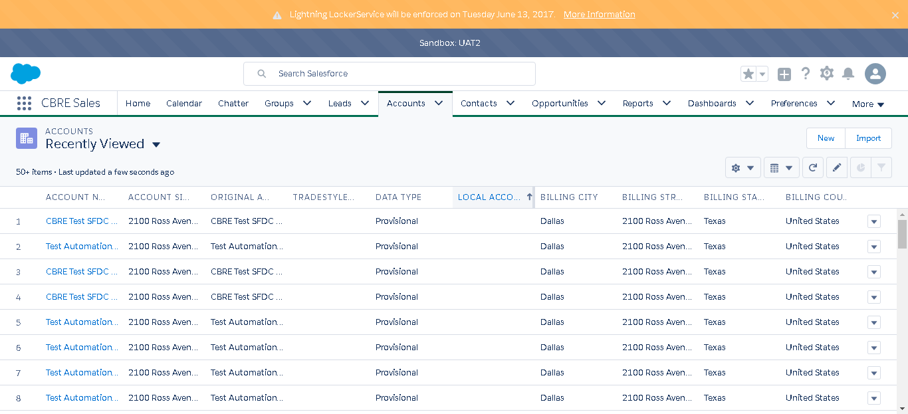

SF.SmokeTestScripts_TC_SF_OBAccountsLandingPage_Instance1_18-Apr-2017_12-05-08_AM_Verify_Account_Landing_Page_Inform

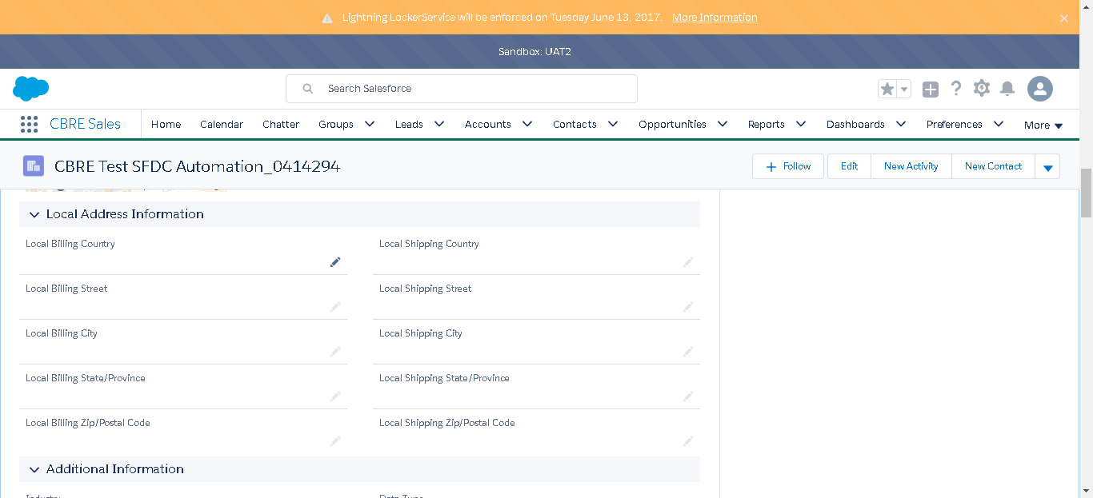

SF.SmokeTestScripts_TC_SF_OBAccountsLandingPage_Instance1_18-Apr-2017_12-05-09_AM_Verify_Account_Landing_Page_Inform



SF.SmokeTestScripts_TC_SF_OBAccountsLandingPage_Instance1_18-Apr-2017_12-05-10_AM_Verify_Account_Landing_Page_Inform



SF.SmokeTestScripts_TC_SF_OBAccountsLandingPage_Instance1_18-Apr-2017_12-05-11_AM_Verify_Account_Landing_Page_Inform



SF.SmokeTestScripts_TC_SF_OBAccountsLandingPage_Instance1_18-Apr-2017_12-05-12_AM_Verify_Account_Landing_Page_Inform



SF.SmokeTestScripts_TC_SF_OBAccountsLandingPage_Instance1_18-Apr-2017_12-05-13_AM_Verify_Account_Landing_Page_Inform



SF.SmokeTestScripts_TC_SF_OBAccountsLandingPage_Instance1_18-Apr-2017_12-05-14_AM_Verify_Account_Landing_Page_Inform

